Ref. No. 2024/08/SH6 Date: 10/08/2024

# Engineer’s Valuation Report Summary Land &Building Valuation

Branch : Indian Bank,Maihar.

Purchaser : Smt. Sunita Sharma

W/o Shri Mam Mohan Sharma

Panel Engineer : Er. Nikhil Sahu

|  |  |  |  |  |
| --- | --- | --- | --- | --- |
| 01. | Purchaser | Smt. Sunita Sharma  W/o Shri Mam Mohan Sharma | | |
| 02. | Survey No. and Registrar Office wherein the title deeds are registered   1. Whether verified with legal opinion Survey No./ Patta No. 2. Extent of Land | LSNo. 558/1/1,557/1/2,557/1/1/2  27,770 Sq.ft | | |
| 03. | a. Locational Address of the Property | Village: Nadan Sharda Prasad, P.H.No. 81(Nadan), NH-30, LSNo. 558/1/1, 557/1/2,557/1/1/2, Tehsil:  Maihar, District:Satna(M.P). | | |
| b. Specify the boundary description on all sides | North | : | Land of Dariyani |
| South | : | NH-30(Maihar - Amarpatan Road) |
| East | : | Land of Gyanendra Sharma |
| West | : | 12 ft Road & Land of Pappu Saket |
| 04. | Details of recent registration   1. Purchaser 2. Seller | -  - | | |

|  |  |  |
| --- | --- | --- |
|  | 1. Extent of the area 2. Registered for Rs. 3. Date of Registration | 27,770 Sq.ft  -  - |
| 05. | Whether the property self acquired or ancestral property  If ancestral property whether VAO certificate is available  If self acquired whether original title deed verified | Self Acquired  Nil Nil |
| 06. | If the building is leased out, terms of lease, unexpired period of lease and possibility of getting vacant possession | Free Hold |
| 07. | Whether the land on which the building stands is owned by the borrower | Yes |
| 08. | Type of construction with details   1. Whether constructed as per approved plan (Enclose photocopy of the approved building plan) 2. Whether any major deviations observed from the approved plan | Nil Nil |
| 09. | 1. Age of the building and the present Condition 2. Life expectancy 3. Locational disadvantages | 2 Years Old  40 Years Nil |
| 10. | 1. Whether property tax has been paid regularly 2. Amount of tax | Nil  Nil |

|  |  |  |  |
| --- | --- | --- | --- |
|  |  |  | |
| 11. | Any other relevant details Whether premises utilized for residential / commercial purposes-  Own / rental occupation / Long lease- If rented, rent yield per month  Whether standard rent has been fixed under Rent Control Act; if so details:  Any dispute between owner and tenant | Commercial  Free hold No  Nill  N.A. | |
| 12. | Legal Encumbrances, if any, (Searches and Investigations made).  Any other details which affects our charge on the property as security | No  No | |
| 13. | Total Area of the land | 27,770 Sq.ft | |
|  | **GROUND FLOOR** | **FIRST FLOOR** |
| Constructed area | 921.62 Sq.ft | 921.62 Sq.ft |
| Year of construction | 2022 | 2022 |
| Type of construction | RCC | RCC |
| Type of roof | RCC Slab | RCC Slab |
| Type of floor | Tiles | Tiles |
| Amenities / Extra fittings –  Replacement Value (Rs. in lacs) | Nil | Nil |
| Estimates / Present value | Rs. 11,06,000.00 | Rs. 11,06,000.00 |
| 14. | **Less :** Depreciation (Rs. in lacs)  Forced / Distress Sale Value (Rs. in lacs)  Availability of civic amenities / Water Electricity Connection | NILL Rs.66,01,000.00  Available Yes | |

|  |  |  |
| --- | --- | --- |
|  | Drainage Connection | Yes |
| Transport / communication | Available |
| Nearest Bus Stop | 6-8 km |
| Nearest Railway Station | Nil |
| 14. | VAO / Guideline value maintained at Registrar Office (copy enclosed) | Rs. 91,80,000.00 |
| 15. | Local / Market rate prevailing at the time of valuation (Basis of valuation) | Rs. 200 per sq.ft |
| 16. | Value arrived at by the undersigned |  |
| and reasons there of |  |
| a. Market Value | Rs. 77,66,000.00 |
| b. Forced/Distress Sale Value | Rs. 66,01,000.00 |
| c. Comparable Sale Value (in the | Not Available |
| vicinity) |  |
| d. Realizable Sale Value | Rs. 69,89,000.00 |

Certified that the property valuation has been done without any interest direct or indirect and the distress sale value has also been taken into account for valuing the property.

Detailed valuation report is enclosed.

# Signature (with seal) Note:

This format is illustrative and additional / any other relevant details may be furnished / added wherever necessary

**DETAILED VALUATION**

|  |  |  |  |
| --- | --- | --- | --- |
| 01. | OWNER NAME | : | Smt. Sunita Sharma  W/o Shri Mam Mohan Sharma |
| 02. | PROPERTY ADDRESS | : | Village: Nadan Sharda Prasad, P.H.No. 81(Nadan), LSNo.558/1/1, 557/1/2, 557/1/1/2, Tehsil:Maihar, District :Satna (M.P.) |
| 04.  05. | PLOT VALUATION  BUILDING VALUATION | :  : | 27,770 sq.ft x 200 per sq.ft = Rs. 55,54,000.00 Say Value Rs. 55,54,000.00  GF-921.62 Sq.ft x 1200 per sq.ft = Rs. 11,05,944 Say Value Rs. 11,06,000.00  FF-921.62 Sq.ft x 1200 per sq.ft = Rs. 11,05,944 Say Value Rs. 11,06,000.00  Total Rs. 22,12,000.00 |
| 06.  07. | MARKET VALUATION REALIZEBLE VALUATION  (90% of market valuation) | :  : | Rs. 77,66,000.00  Rs. 69,89,400.00  Say Value Rs. 69,89,000.00 |
| 08.  09. | DISTRESS VALUATION  (85% of market valuation)  GUIDELINE VALUATION (S.No. 1441) | :  : | Rs. 66,01,100.00  Say Value Rs. 66,01,000.00  Plot Value : 27,770 sq.ft x Rs. 250.92 per sq.ft = Rs. 69,68,048.4 Say Value Rs. 69,68,000.00  Building Value : Rs. 22,12,000.00 Total Value Rs. 91,80,000.00 |

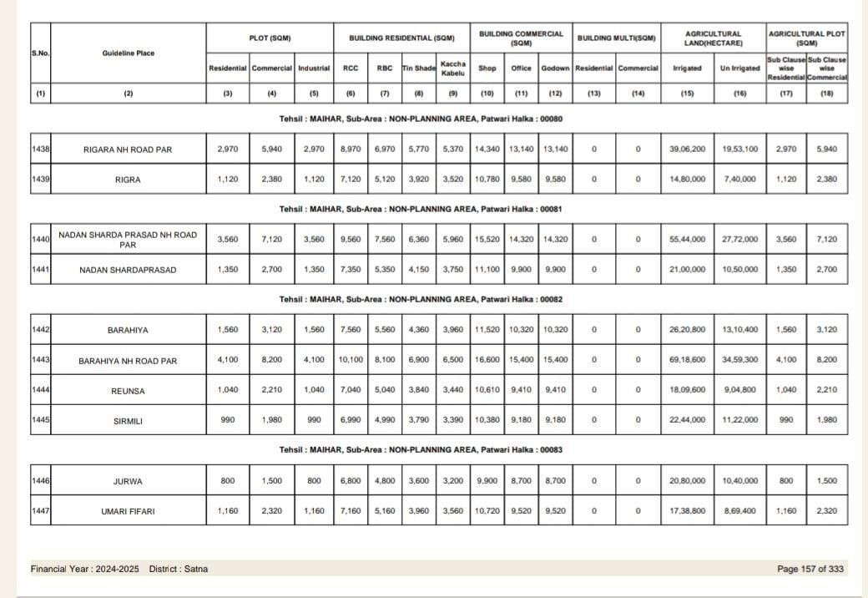

Refer to Satna Guideline S.No. 1441 of Page No. 38

